MedCheckMe App
Design Team: Ryan Potechin, Thomas Young, Samantha Lee, Trevor Lau, Justus Morales, Sophie Chabot
Design Advisor: Miguel Mireles Nunez
Design Sponsor: Marc Blumenthal, Social Ventures Foundation

Motivation, Background, and Overview
Lack of access to medical checkups in developing countries has a significant impact on global health. According to the WHO, upwards of 3.5 billion people lack access to necessary healthcare services. The Social Ventures foundation project, the MedCheckMe App, aims to address this issue with a multi-purpose application for health monitoring. The app will utilize a mobile phone to create jobs for individuals to offer affordable diagnostic exams within their local community. Although various apps for performing diagnostic tests exist, there are no existing solutions combining various tests. Additionally, existing solutions are not catered towards developing nations. The preliminary MedCheckMe app seeks to overcome these limitations by providing diagnostic capabilities in the following four fields: cardiology, dermatology, optometry, and audiology. The first iteration of the application will be implemented in Haiti and Costa Rica with the aim of providing health care access to underserved, remote communities.

Key Design Requirements
- Diagnostic check-ups shall be kept below $1
- App shall provide pertinent diagnostic tests conforming to regulatory standards
- App shall not require constant internet connection
- Patient information shall be kept confidential and secure

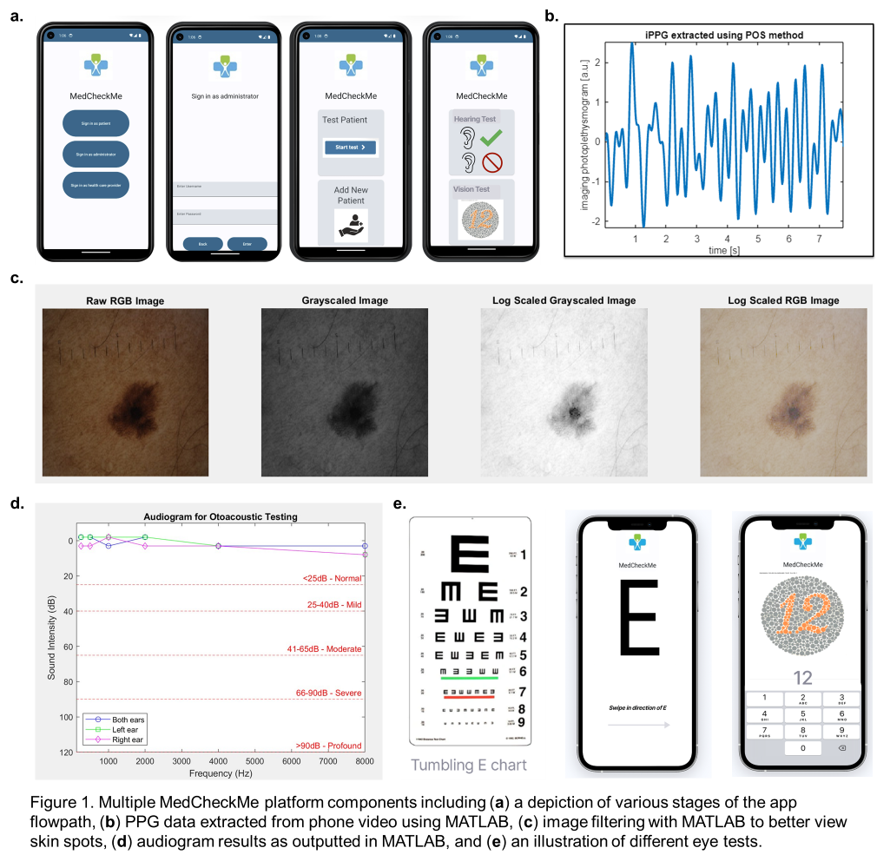
Design Solution/Procedure Summary
The MedCheckMe platform is a multi-faceted platform that integrates a secure patient database with basic medical tests important to health monitoring and diagnosis. The platform utilizes the capabilities of a low-cost smartphone and common attachments to perform cardiology, dermatology, optometry, and audiology checkups. The gathered data is encrypted and stored locally on the phone with infrastructure in place to upload the data to a cloud database when internet connection is available. The data collected is only accessible by the patients themselves and approved physicians. Additionally, the MedCheckMe can be expanded to integrate into hospital systems and to support other medical tests such as urinalysis, respiratory, and retinal checkups. Components of the MedCheckMe platform are featured in Figure 1a-e, and will be discussed in further detail in the following sections.

Cardiology
The MedCheckMe app plans to measure heart rate and blood pressure. These can be collected with photoplethysmography (PPG). PPG is an optical technique used to detect volumetric changes in blood circulation. MATLAB was used to derive PPG signals from videos of a finger pressed against a phone camera. An example waveform is shown in Figure 1b. The heart rate is derived via a set of functions incorporating both discrete Fourier and wavelet transforms to identify peaks corresponding to respiration and allowing the system to decompose an incoming signal into various frequency components. Analysis of this spectrum aids in isolating the heart rate signal from excessive noise. The blood pressure can be estimated using a machine learning algorithm trained on hospital data such as the MIMIC III dataset. The machine learning algorithm is used to analyze extracted features including systolic peak, diastolic peak, and dicrotic notch and map these features to waveforms resulting in an estimate for blood pressure values. The blood pressure is not entirely functional in this proof-of-concept app.

Dermatology
MATLAB was used to filter phone camera images of skin abnormalities to allow for better analysis, as seen in Figure 1c. For the app, images will be further magnified with the addition of a low cost, dermoscopic device. Currently, a jeweler’s lens with high magnification is used. Consultation with dermatologists confirmed that the magnification and transformations present adequate image quality for effective analysis. In the future, with sufficient training material these images could be analyzed with machine learning models.

Optometry
The MedCheckMe platform measures both visual acuity and color blindness, with the aspiration of providing low-cost vision exams.
Visual acuity is a measurement of clarity and sharpness of one's vision and provides information for diagnosing and managing eye diseases. Visual acuity is measured using Tumbling E charts, as shown in Figure 1e. The ability of the patient to recognize the orientation of the letter E at various sizes allows for an effective measurement of visual acuity. The proof of concept for this approach was made in MATLAB.

Audiology
The audiology portion of the app seeks to assess hearing using the pure tone test method. Payback of a range of frequencies (250-8000 Hz) at increasing decibels is performed within earbuds. This test method is repeated three times: one for both ears, the left and the right ear. The results can be plotted on an audiogram, like seen in Figure 1d. The audiogram shown was designed and measured in MATLAB.

Database
To store patient information, a SQL “relational” database was designed. A relational database was chosen for its simple, robust organization, ease of use, and data security. The database was prototyped in SQLite, an open source, locally hosted database software. A more refined version of the database was then prototyped using Postgres SQL, one of the most popular open-source database software. Based on an analysis of Microsoft Azure, Amazon Web Services, and Google Cloud, the refined database was hosted using Google Cloud due to similar pricing and sponsor affiliations with Google.

Phone Selection
Various phone models and operating systems (OS) were explored to host the MedCheckMe application. Android OS was chosen after a robust trade study comparing cost, camera quality, battery life, and storage. Additionally, Android OS is often easier to integrate with open-source software and external hardware, which may be relevant in later versions of the app, which would like to incorporate devices and hardware in the future. The Google Pixel phones were chosen as the ideal model due to high performance in the trade study and sponsor affiliations with Google. When compiling the application on Android Studio software, a virtual Google Pixel 5 phone was used to run the app.

Results and Integration
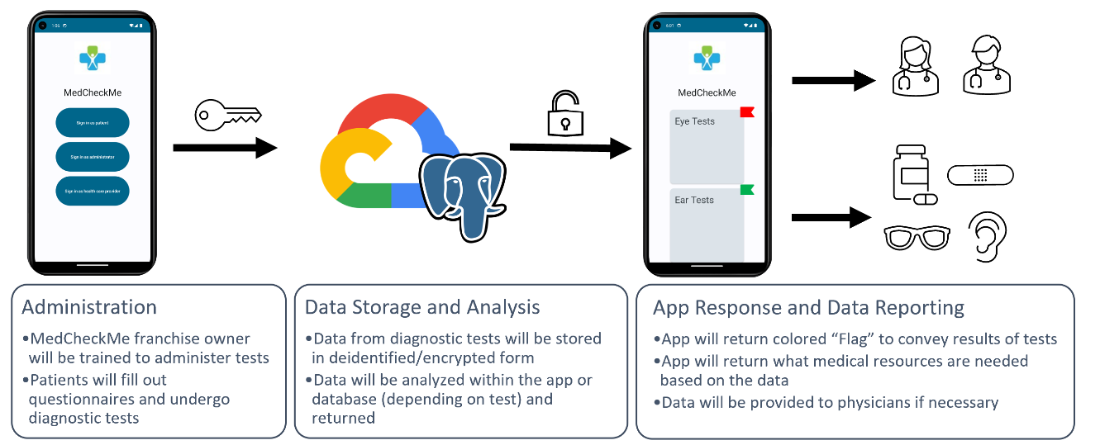
Each aspect of the MedCheckMe platform was coded separately using MATLAB, python, or SQL. In order to integrate the components together, Android Studio was used to compile all of the tests within an app. At the conclusion of capstone, a totally seamless integration has not yet been achieved, with most cardiology and dermatology not yet integrated into the platform. However, the proof of concept for the desired flowpath of the app has been created, and was pitched to Partners in Health in Haiti on November 28th, 2023. The figure above depicts the desired flowpath of the entire MedCheckMe Platform:

